Ex. No. 1 | Design a Website Using HTML5
Date of Exercise | 20.07.2026
GitHub Host Link | https://praneettigga.github.io/web-tech-lab/

Aim
To design and develop a simple yet structured HTML5 website for an Interior Design Studio ("Zen Spaces") using essential semantic tags and formatting features such as headings, paragraphs, images, tables, lists, different types of hyperlinks, comments, <div> sections, and background and text colors applied through internal CSS.
Description
HTML5 document structure: The page begins with the <!DOCTYPE html> declaration, followed by the <html lang="en"> root element, a <head> containing <meta charset="UTF-8"> and <title>, and a <body> containing all visible content.
Headings and paragraphs: <h1> to <h4> define the content hierarchy, and <p> holds blocks of text.
Hyperlinks: The anchor tag <a> is used for an external link (target="_blank" with rel="noopener noreferrer"), internal/bookmark links to sections using id values (href="#projects"), links to other pages (pages/gallery.html), an email link (mailto:), a phone link (tel:) and a clickable image link (an <img> nested inside <a>).
Images: <img> embeds pictures using the src, alt and width attributes; alt text provides an accessible description.
Tables: <table>, <tr>, <th> and <td> arrange project details (image, name, room type, style) in rows and columns.
Lists: A description list (<dl>, <dt>, <dd>) describes the services; an ordered nested list (<ol> inside <li>) shows the design process; an unordered nested list (<ul> inside <li>) shows rooms and styles.
Comments and <div>: HTML comments (<!-- ... -->) label each module, and <div> elements with class and id attributes divide the page into navigation, hero, welcome, project, services and contact sections.
Internal CSS: A <style> block in the head sets the background color, text color, fonts, spacing, borders and hover effects using element, class and pseudo-class selectors, giving the site a consistent green and gold theme.
Procedure:
1. Select the application theme: an Interior Design Studio website named "Zen Spaces".
2. Create a project folder with home.html, an images folder (interior-1.jpg to interior-4.jpg) and a pages folder (gallery.html, about-us.html, contact.html, projects.html) in VS Code.
3. Begin home.html with the <!DOCTYPE html> declaration and add the <html>, <head> (with <meta charset> and <title>) and <body> tags.
4. Add an HTML comment with the register number and website theme at the top of the file.
5. Write internal CSS inside <style> to apply the background color, text color, fonts, borders, table and list styles.
6. Create the navigation <div> with an <h1> heading and a list of internal links (#home, #projects) and page links (gallery, about us, contact).
7. Create the hero <div> with <h1> and <h2> headings, a clickable image link (external link opening in a new tab using target="_blank") and a bookmark link to the Projects section.
8. Create the welcome <div> with <h3>, <h4> and multiple <p> tags, and add an external GitHub hyperlink.
9. Create the projects <div> containing a table with a header row and three project rows, each with an image.
10. Create the services <div> with a description list (<dl>), an ordered nested list (<ol>) and an unordered nested list (<ul>).
11. Create the contact <div> with an email link (mailto:) and a phone link (tel:).
12. Add an HTML comment before each module/section and keep the code properly indented.
13. Create the remaining pages (gallery, about us, contact, projects) with the same navigation bar.
14. Save the files, run a local server (localhost) and open the pages in a browser to verify the output.
15. Push the code to GitHub and host it using GitHub Pages to obtain the deployment link.
Program
home.html
<!DOCTYPE html>
<!--URK24CS1040-->
<!--Website Theme : Interior Design Studio-->
<html lang="en">
<head>
<meta charset="UTF-8">
<title>Interior Design Studio</title>

<style>
body {
background-color: #f8f5ef;
color: #2f3e2f;
font-family: Arial, sans-serif;
margin: 0;
padding: 0;
}

.navbar, .hero-section, .welcome-section, .project-section, .services-section, .contact-section {
padding: 20px;
margin: 20px;
border-radius: 10px;
background-color: #fffdf8;
}

.navbar {
background-color: #1f4d3a;
color: white;
}

.navbar h1 {
color: #d4af37;
}

.navbar ul {
list-style-type: none;
padding: 0;
}

.navbar li {
display: inline;
margin-right: 15px;
}

.navbar a {
color: #f5e6a8;
text-decoration: none;
}

.navbar a:hover {
color: #ffd700;
}

h1, h2, h3, h4 {
color: #1f4d3a;
}

a {
color: #b8860b;
text-decoration: none;
}

a:hover {
text-decoration: underline;
color: #8b6f1e;
}

img {
border: 3px solid #d4af37;
border-radius: 8px;
margin-top: 10px;
}

table {
width: 100%;
border-collapse: collapse;
margin-top: 15px;
background-color: white;
}

th {
background-color: #1f4d3a;
color: white;
}

th, td {
border: 1px solid #c8b273;
padding: 10px;
text-align: center;
}

dl, ol, ul {
margin-top: 10px;
margin-bottom: 10px;
}

dt {
font-weight: bold;
color: #1f4d3a;
}

dd {
margin-bottom: 10px;
}

hr {
border: 1px solid #d4af37;
}
</style>
</head>
<body>

<!-- Navigation Section -->
<div class="navbar" id="top">
<h1>ZEN SPACES</h1>
<ul>
<li><a href="#home">Home</a></li>
<li><a href="pages/gallery.html">Gallery</a></li>
<li><a href="#projects">Projects</a></li>
<li><a href="pages/about-us.html">About Us</a></li>
<li><a href="pages/contact.html">Contact</a></li>
</ul>
<hr>
</div>

<!-- Hero Section -->
<div class="hero-section" id="home">
<h1>India's Most Trusted Interior Company</h1>
<h2>Crafting Elegant and Functional Interior Design</h2>
<h2>Kitchen | Bedroom | Living | Dining</h2>
<a href="https://github.com/praneettigga/web-tech-lab" target="_blank" rel="noopener noreferrer">
<img src="images/interior-1.jpg" alt="Modern Living Room Interior" width="300">
</a>
<p><a href="#projects">View Our Projects</a></p>
<hr>
</div>

<!-- Welcome Section -->
<div class="welcome-section" id="welcome">
<h3>Welcome to Zen Spaces</h3>
<h4>Welcome to our award winning Interior Design Studio</h4>
<p>
We specialize in creating stylish, innovative, and functional interiors that blend
creative aesthetics with practical design solutions.
</p>
<p>
Every space we design is thoughtfully crafted to reflect our clients’ personality and
lifestyle, while maintaining a modern and sophisticated look.
</p>
<p>
With a fresh perspective and high-end execution, we turn ideas into inspiring spaces.
</p>
<p>You can visit this website's GitHub at:</p>
<a href="https://github.com/praneettigga/web-tech-lab" target="_blank" rel="noopener noreferrer">GitHub</a>
</div>

<!-- Project Section -->
<div class="project-section" id="projects">
<h3>Projects</h3>
<p>Here are some of our featured interior design projects.</p>

<table>
<tr>
<th>Project Image</th>
<th>Project Name</th>
<th>Room Type</th>
<th>Style</th>
</tr>
<tr>
<td>
<a href="https://github.com/praneettigga/web-tech-lab" target="_blank" rel="noopener noreferrer">
<img src="images/interior-1.jpg" alt="Modern living room interior project" width="200">
</a>
</td>
<td>Urban Elegance</td>
<td>Living Room</td>
<td>Modern</td>
</tr>
<tr>
<td>
<a href="https://github.com/praneettigga/web-tech-lab" target="_blank" rel="noopener noreferrer">
<img src="images/interior-2.jpg" alt="Elegant bedroom interior project" width="200">
</a>
</td>
<td>Serene Retreat</td>
<td>Bedroom</td>
<td>Minimalist</td>
</tr>
<tr>
<td>
<a href="https://github.com/praneettigga/web-tech-lab" target="_blank" rel="noopener noreferrer">
<img src="images/interior-3.jpg" alt="Contemporary dining room interior project" width="200">
</a>
</td>
<td>Golden Feast</td>
<td>Dining Room</td>
<td>Contemporary</td>
</tr>
</table>
</div>

<!-- Services and Design Details Section -->
<div class="services-section" id="services">
<h3>Our Services and Design Process</h3>
<p>Zen Spaces offers complete interior design solutions for modern homes and apartments.</p>

<dl>
<dt>Modular Kitchen</dt>
<dd>Smart kitchen layouts with modern cabinets, storage units, and elegant finishes.</dd>

<dt>Bedroom Interiors</dt>
<dd>Comfortable and stylish bedroom designs with wardrobes, lighting, and custom furniture.</dd>

<dt>Living Room Design</dt>
<dd>Beautiful living spaces designed for comfort, family interaction, and visual appeal.</dd>
</dl>

<ol>
<li>Design Consultation
<ol>
<li>Understand client requirements</li>
<li>Discuss budget and space planning</li>
</ol>
</li>
<li>Concept Development
<ol>
<li>Create layout ideas</li>
<li>Select materials and colors</li>
</ol>
</li>
<li>Execution
<ol>
<li>Install furniture and decor</li>
<li>Complete final finishing</li>
</ol>
</li>
</ol>

<ul>
<li>Rooms We Design
<ul>
<li>Living Room</li>
<li>Bedroom</li>
<li>Dining Room</li>
</ul>
</li>
<li>Design Styles
<ul>
<li>Modern</li>
<li>Minimalist</li>
<li>Contemporary</li>
</ul>
</li>
</ul>
</div>

<!-- Contact Section -->
<div class="contact-section" id="contact-home">
<h3>Contact Us</h3>
<p>Email: <a href="mailto:customerservice@zenspaces.com">customerservice@zenspaces.com</a></p>
<p>Phone: <a href="tel:+9123456789">+91 23456 789</a></p>
</div>

</body>
</html>

pages/gallery.html
<!DOCTYPE html>
<html lang="en">
<head>
<meta charset="UTF-8">
<title>Gallery</title>
</head>

<body style="background-color: white;">

<!-- Navigation Section -->
<div class="navbar" id="top">
<h1>ZEN SPACES</h1>
<ul>
<li><a href="../home.html">Home</a></li>
<li><a href="gallery.html">Gallery</a></li>
<li><a href="projects.html">Projects</a></li>
<li><a href="about-us.html">About Us</a></li>
<li><a href="contact.html">Contact</a></li>
</ul>
<hr>
</div>

<h1>Gallery Page</h1>

<ul>
<li><img src="../images/interior-1.jpg" alt="Modern living room interior"></li>
<li><img src="../images/interior-2.jpg" alt="Elegant bedroom interior"></li>
<li><img src="../images/interior-3.jpg" alt="Stylish dining room interior"></li>
<li><img src="../images/interior-4.jpg" alt="Luxury modular kitchen interior"></li>
</ul>
</body>
</html>

pages/about-us.html
<!DOCTYPE html>
<html lang="en">
<head>
<meta charset="UTF-8">
<title>About Us</title>
</head>

<body style="background-color: white;">

<!-- Navigation Section -->
<div class="navbar" id="top">
<h1>ZEN SPACES</h1>
<ul>
<li><a href="../home.html">Home</a></li>
<li><a href="gallery.html">Gallery</a></li>
<li><a href="projects.html">Projects</a></li>
<li><a href="about-us.html">About Us</a></li>
<li><a href="contact.html">Contact</a></li>
</ul>
<hr>
</div>

<h1>About Us</h1>

<div>
<p>“Made for you” may be an accurate phrase to express what we do in interiors. We have been designing and executing exquisite home interiors since 2004. Custom-made interior is the best way to ensure that modular kitchen, wardrobes and other furniture perfectly fits to the spaces. Our interior designers possess impeccable ability to understand client’s requirements and provide the best space planning for a house or flat. D’LIFE’s fully equipped modular kitchen is distinct with its unique design and most modern features. We plan and make contemporary style furniture for bedrooms, living and dining rooms as well. Innovative ideas, creative designs and ability to deliver the promises on time enables us to retain the leadership in this field.</p>
</div>

</body>
</html>

pages/contact.html
<!DOCTYPE html>
<html lang="en">
<head>
<meta charset="UTF-8">
<title>Contact</title>
</head>

<body style="background-color: white;">

<!-- Navigation Section -->
<div class="navbar" id="top">
<h1>ZEN SPACES</h1>
<ul>
<li><a href="../home.html">Home</a></li>
<li><a href="gallery.html">Gallery</a></li>
<li><a href="projects.html">Projects</a></li>
<li><a href="about-us.html">About Us</a></li>
<li><a href="contact.html">Contact</a></li>
</ul>
<hr>
</div>

<div>
<h1>Contact The Best Home Interior Designers at:</h1>
<a href = "mailto:customerservice@zenspaces.com">Email: customerservice@zenspaces.com</a>
<br>
<a href = "tel:+9123456789">Phone: +9123456789</a>
</div>

</body>
</html>

pages/projects.html
<!DOCTYPE html>
<html lang="en">
<head>
<meta charset="UTF-8">
<title>Projects</title>
</head>

<body style="background-color: white;">

<!-- Navigation Section -->
<div class="navbar" id="top">
<h1>ZEN SPACES</h1>
<ul>
<li><a href="../home.html">Home</a></li>
<li><a href="gallery.html">Gallery</a></li>
<li><a href="projects.html">Projects</a></li>
<li><a href="about-us.html">About Us</a></li>
<li><a href="contact.html">Contact</a></li>
</ul>
<hr>
</div>

<h1>Projects Page</h1>

<div>
<p>This page is still in progress...</p>
</div>

</body>
</html>

Output
Home Page (http://localhost:8123/home.html)
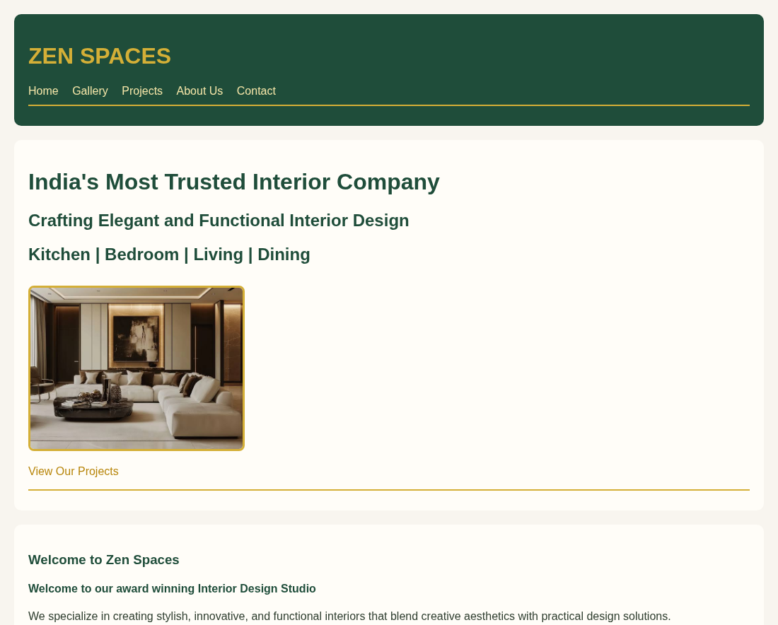
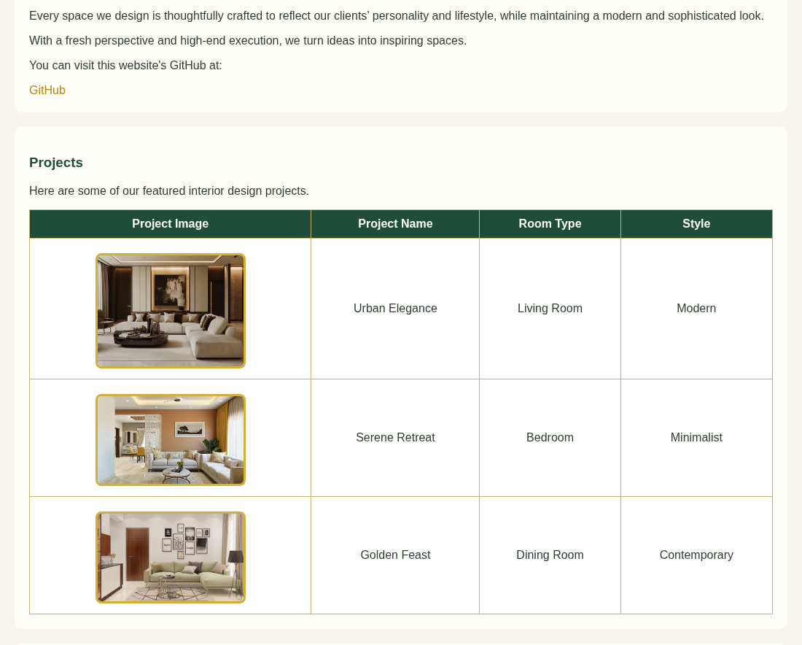
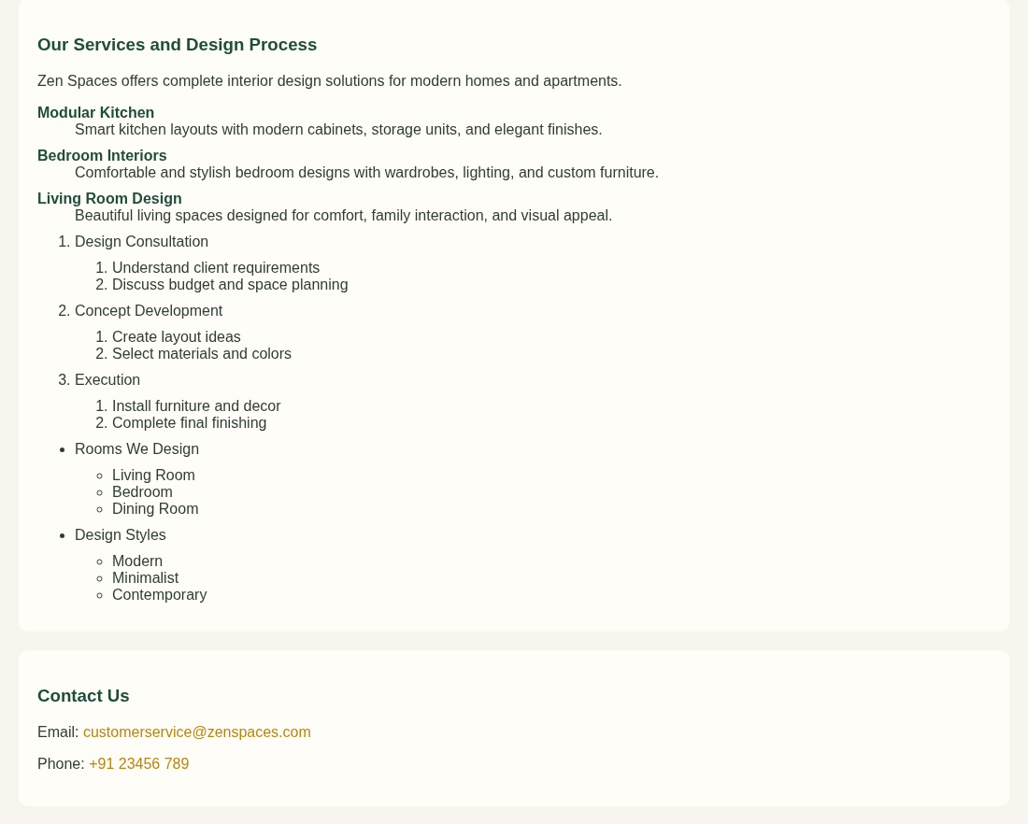
Figure 1: Home page (complete page, shown in three parts)
Gallery Page
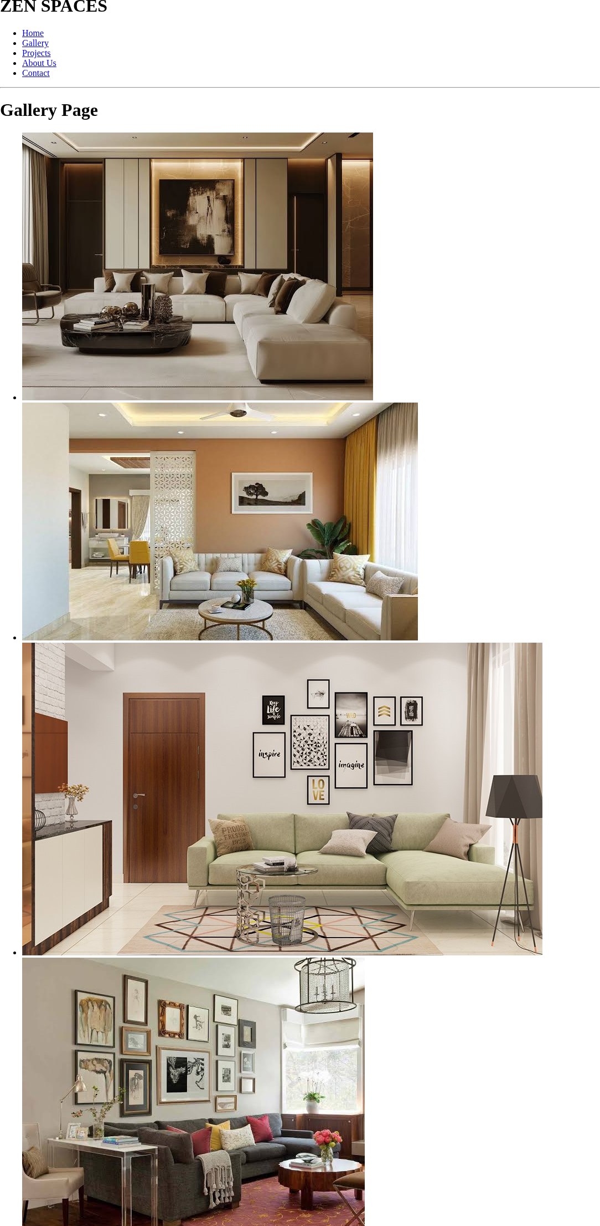
Figure: Gallery Page
About Us Page
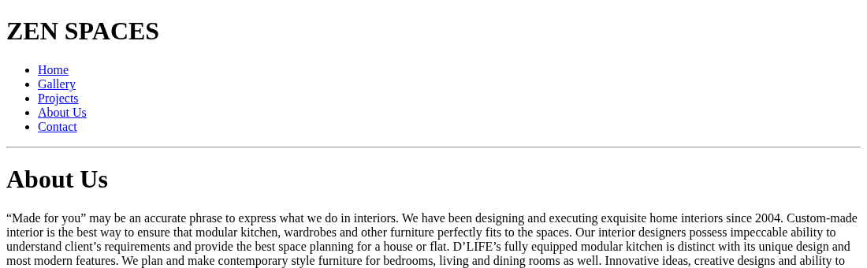
Figure: About Us Page
Contact Page
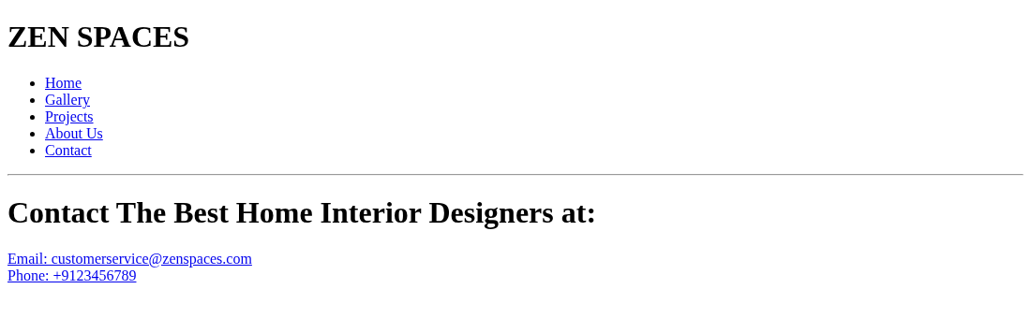
Figure: Contact Page
Projects Page
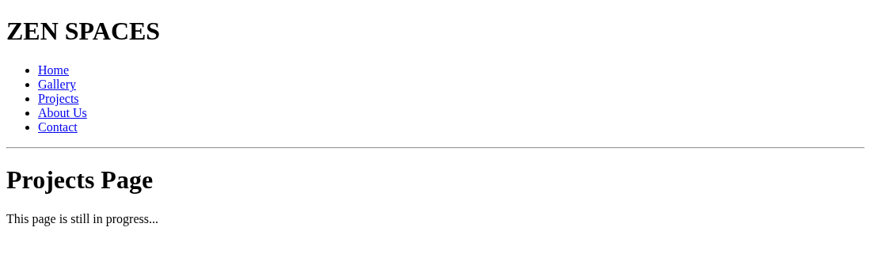
Figure: Projects Page
Result
The given HTML5 web page for the Interior Design Studio theme was successfully designed and executed using appropriate tags, formatting elements, hyperlinks, tables, lists, comments and internal CSS. The output matched the expected layout and content criteria and was verified on localhost and hosted on GitHub Pages.

